Compiling Open-Source YOLO Models for Deployment on the Hailo 8L AI Processor
Mohomad Sabur

Introduction
The Hailo 8L chip used on the Raspberry Pi5 Hat is an AI processor capable of 13 tera-operations per second or TOPS. A more capable 26 TOPS option is available for the Raspberry Pi, but for our project use the 13 TOPS version was sufficient. The Hailo 8L processor is considered an Edge AI device because all computations are performed locally without the use of the Cloud or Internet. The Hailo 8L is a good match for smaller devices like the Pi5 due to its low latency and low power usage of 1.5W.

Problem
One shortcoming of the Hailo 8L processor is that in order to run an AI model, the model has to be converted to a Hailo Executable File or .hef file. The .hef file is a proprietary file type that is exclusive to the Hailo aqrchitecture. The model we selected for our project was the Yolo model which is natively built on PyTorch. (Ultralytics, n.d.). The native PyTorch or .pt file will not work directly with the Hailo chip without conversion.
The conversion tool offered by Hailo is the Dataflow Compiler application or DFC. The Hailo DFC can convert Tensorflow or ONNX (Open Neural Network Exchange) files. The current release of the Hailo DFC can only run on X86 machines (PC+ Linux) and not on the Raspberry Pi5 itself. Seen on figure 1
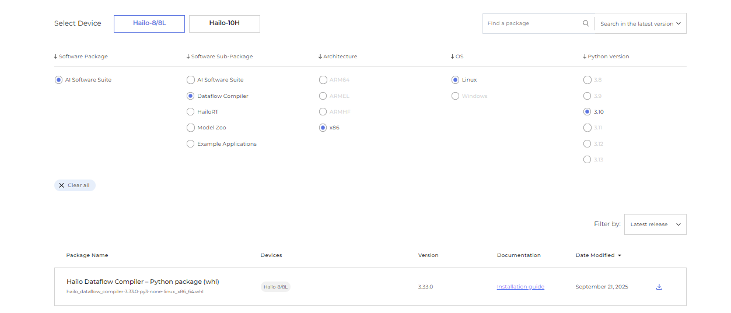
Figure 1
Three problems now exits, the first problem is that the native YOLO model is a PyTorch model. The second problem is that the Hailo DFC cannot directly convert the PyTorch model to the Hailo useable .hef file. The third problem is that the Hailo DFC will not work on the Pi5, and a separate computer must be used. Two separate model conversion processes need to occur to use the YOLO mode with the Hailo AI 8L processor.

Solution
To solve these challenges, first we must convert the YOLO model from .pt to .onnx. These instructions are posted on the Ultralytics document site. Detail instructions using python are seen in figure 1 below.

Figure 2

Now that we have a YOLO onnx model that the Hailo DFC can compile, we must use our x86 machine running Linux (Ubuntu 24.04 in this example) to convert the YOLO onnx model to the Hailo proprietary .hef file since the Pi5 Arm 64 processor is not compatible with the Hailo DFC.
The Hailo dataflow compiler can now process the YOLO ONNX file to an intermediate file called the Hailo Architecture Runtime or .har file. The .har file is then quantized to a .har quantized file. The .har quantized file is then finally converted to the Hailo Executable file or .hef that the Hailo 8L can now process. See Figures 3,4,5
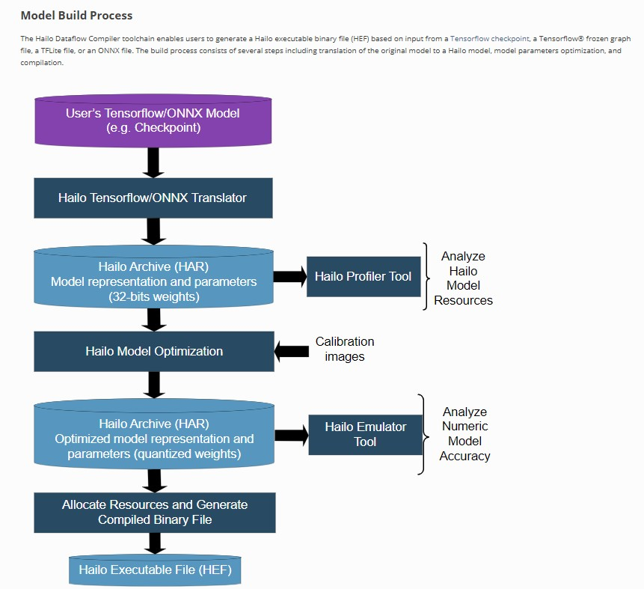
Figure 3
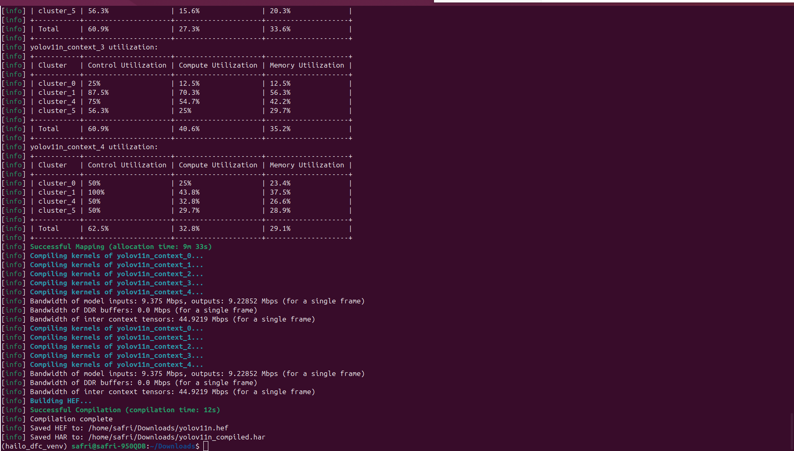
Figure 4
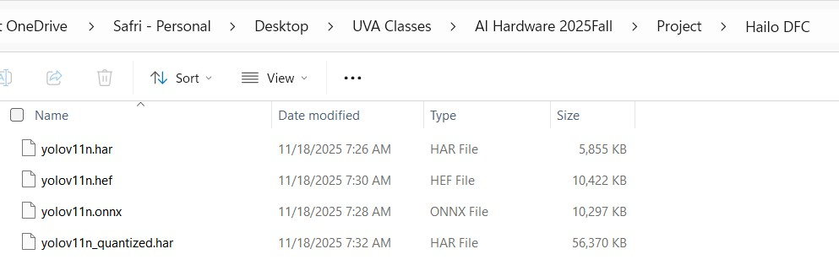
Figure 5

Summary
After conversion you will have 4 distinct file, the onnx file we started the conversion with, followed by the intermediate .har and quantized .har and finally the Hailo 8L useable .hef file. With the .hef file we can now successfully run the YOLO 11 model on the Raspberry Pi5 with the Hailo 8L AI hat. The level of difficulty in my opinion is intermediate since its requires a four step conversion process along with the use of programming a second x86 machine with Linux in order to use the Hailo Dataflow Complier Software. This can certainly add to the time to deployment of AI models that are not already converted to the .hef file format.

Works Cited
Ultralytics . (n.d.). ONNX Export for YOLO. Retrieved from https://docs.ultralytics.com/integrations/onnx/#summary
Ultralytics. (n.d.). Ultalytics YOYO Docs. Retrieved from https://docs.ultralytics.com/integrations/onnx/

